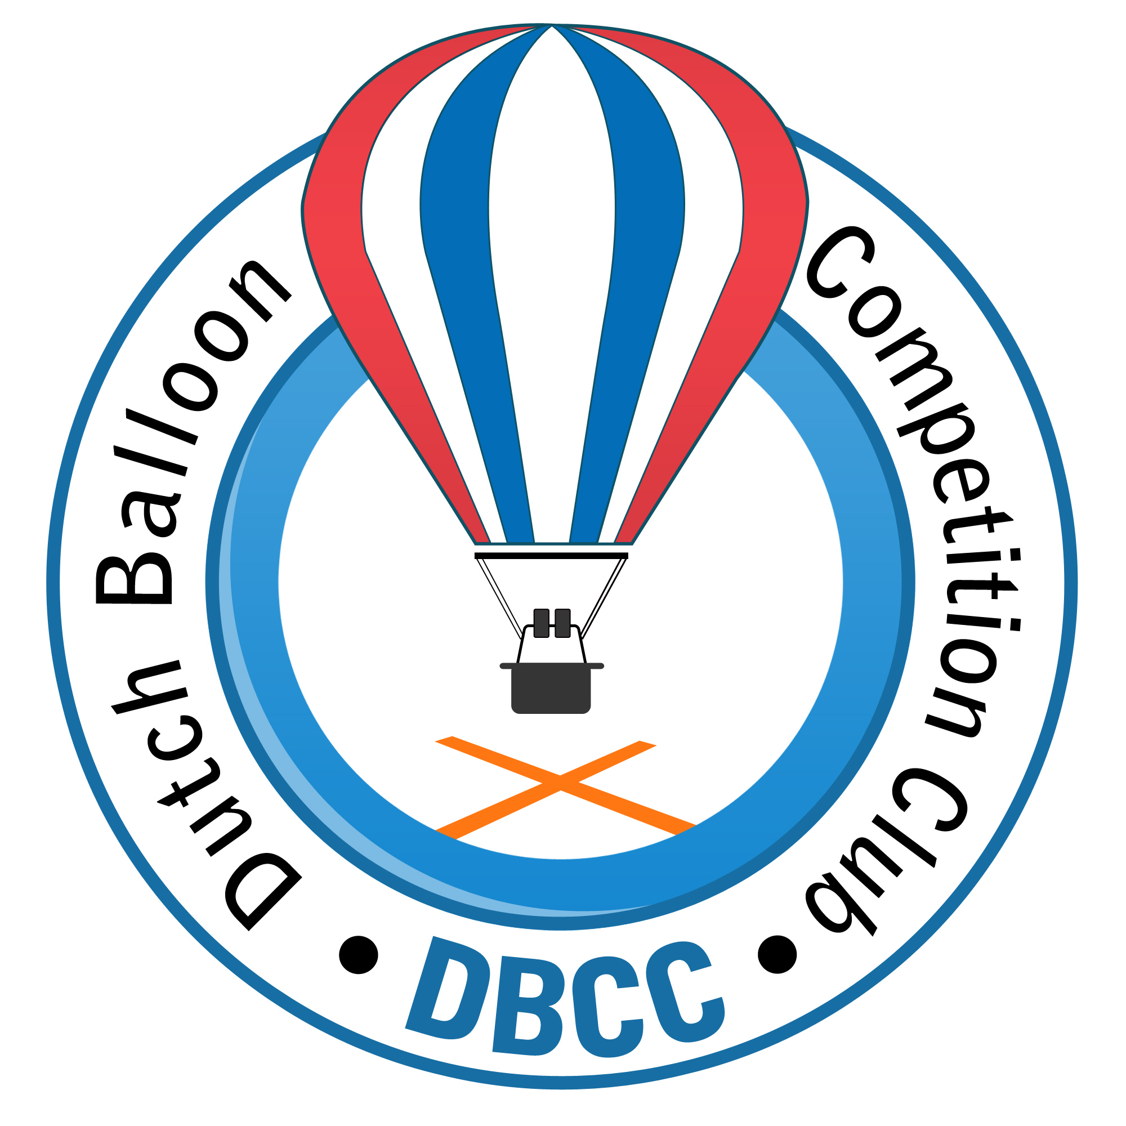
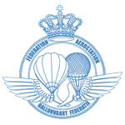
Invitation for:

DUTCH BALLOON TROPHY 2013
Wezuperbrug (NL - Drenthe)
8 u/i 12 May 2013

35 th Dutch Championships and Belgian Championships 2013

The competition will be organised by the Dutch Balloon Competition Club on behalf of the KNVVL and in co-operation with the sports committee of the KBBF.
Location:
Rekreatiepark 't Kuierpadtien
Oranjekanaal NZ 10
7853 TA Wezuperbrug (NL)
Telephone: 0031-591-381415 Fax: 0031-591-382235
E-mail: info@kuierpad.nl

Competition Direction: Zoltán Pálhegyi (HU)

Rules: According latest AXMER rules and with FAI loggers.
Date: 8 u/i 12 may 2013
Check-in: 8 may 2013 between 18.30/19.30 at the competition centre
General Briefing: 8 may 2013 in the evening at 20:00 in the briefingtent
First flight: Thursday morning 9 may 2013
Last flight:: Sunday morning 12 may 2013 (except rule 1.2.2)
Price giving: Sunday 12 may 2013

Entry closing date: 31th Mar 2013

Entry fee: € 350,- incl. 2 maps (with PZ,s and other competition data).

Accommodation: At the park you can rent 6 persons bungalows for the reduced price
of € 350,- for this period (Wednesday appr. 15.00 hr until price giving). These are situated next to the launch field and the briefing tent. Foreign pilots can contact Bert Stuiver for accommodation.
For Belgian and Dutch pilots it's preferable to contact Gerjan Kleefman at the park directly by e-mail: gerjan@vakantie-in-drenthe.nl

Meals: There is a possibility to have meals with coffee and cakes before morning flight, breakfast after morning flight and dinner before evening flight. Costs € 15,00 pro person per day (total € 45,00 pro person for Thursday u/i Saturday). Tickets for Sunday incl. Gala dinner/buffet will cost € 17,50,- p.p. Tickets will be handed out at check-in.

Propane: The used amount will be charged after the competition at cost price.

Insurance: According European regulations.

Entry form: Can be sent before 31 March 2013 to:

Dutch Balloon Competition Club
De Gheynstraat 10
6717 RG EDE
info@dbcc.nl
or to:

Bert Stuiver, Dilweg 1,
7873 BN Odoorn.e-mail info@high5ballooning.nl
Tel: 0031-591-513467 mob. 0031-646204401

Entry is valid after receiving entry fee before 1 april 2013.
Account number 3822.45.709
IBAN NL17 RABO 0382 2457 09
BIC code: RABONL2U
Attn. Dutch Balloon Competition Club.

More INFO you can find or will be published on the websites:

www.dbcc.nl www.nkballonvaren.nl www.kuierpad.nl

