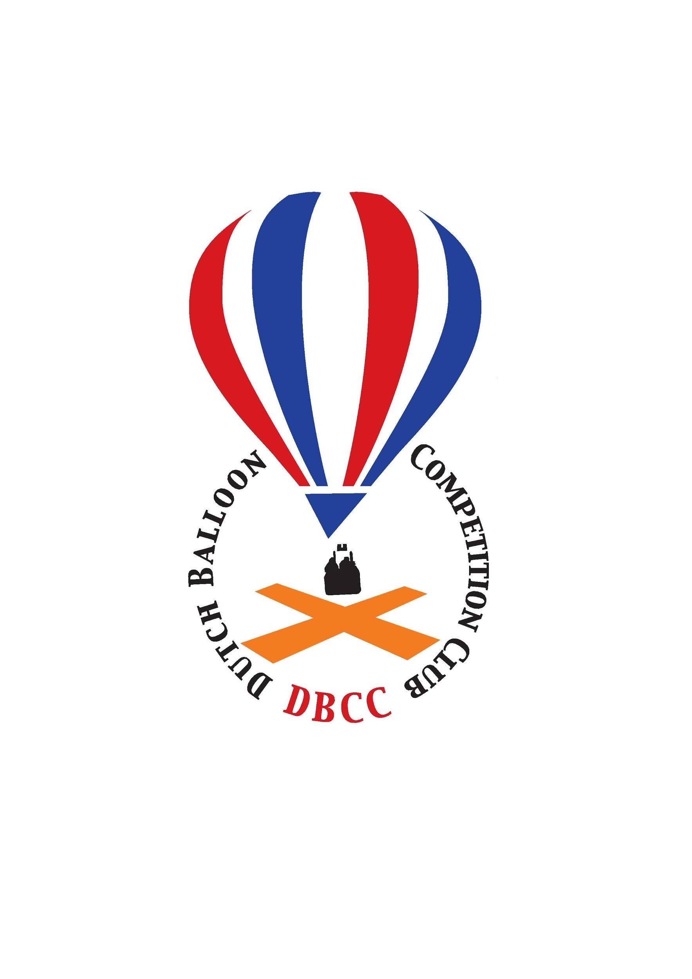

**Invitation for:**

**DUTCH BALLOON TROPHY 2018**

**Gramsbergen (NL - Drenthe)**

**9 u/i 13 May 2018**

**Dutch, Belgian and Luxembourg Championships 2018**

The competition will be organised by the Dutch Balloon Competition Club on behalf of the KNVVL and in co-operation with the sports committee of the KBBF and the Luxembourg Balloon Club.

Location:

Recreational park ‘t Hooge HoltBoslaan 1  
7783 DD Gramsbergen

Competition Director: Martin Wegner (GER)

Rules: According latest AXMER rules and with FAI loggers.

Date: 9 u/i 13 may 2018

Check-in: 9 may 2018 between 17.30/19.30 at the competition centre

General Briefing: 9 may 2018 in the evening at 20:00 at the competition centre

First flight: Thursday morning 10 may 2018

Last flight:: Sunday morning 13 may 2018

Price giving: Sunday 13 may 2018

Entry closing date: **31 January 2018**

for the first round only for the Dutch, Belgian and Luxembourg pilots. After this date entries for Benelux pilots still open but not quaranteed.

**1th March 2018**

the second round also open for other international pilots (benelux+international) up to the maximum of 35 pilots.

Entry fee: € 375,- incl. 1 map (with PZ,s and other competition data).

Extra maps can be ordered for 25,00 per map.



Accommodation: At the park you can rent several bungalow sizes and types for 4 nights.

6 persons € 428,60

5 persons € 412,30

4 persons € 396,00

Upgrade to plus bungalow € 50,00 or € 60,00 with sauna and solarium.

Extra night € 40,00 per accommodation.

The accommodation can be booked directly at the park: [booking@dormioholidays.nl](mailto:booking@dormioholidays.nl) or +31 263537725

Don’t forget to mention that the booking will be according the offer for the special balloon arrangement for the event according above mentioned prices.ys.nl

+31 26 353 77 2

Meals: There is a possibility to light meals with coffee and cakes before morning flight, breakfast after morning flight and dinner before evening flight. Costs € 20,00 pro person per day (total € 60,00 pro person for Thursday u/i Saturday). Tickets for Sunday incl. Gala dinner/buffet will cost € 25,00,- p.p. Tickets will be handed out at check-in.

Propane: The used amount will be charged after the competition at cost price.

Insurance: According European regulations.

Entry form: Can be sent to:

Dutch Balloon Competition Club  
 De Gheynstraat 10  
 6717 RG EDE  
 [info@dbcc.nl](mailto:info@dbcc.nl)

**Entry is valid after receiving entry fee before final entry closing date 1th of March 2018.**

IBAN NL17 RABO 0382 2457 09

BIC code: RABONL2U

Attn. Dutch Balloon Competition Club.

More INFO you can find or will be published on the websites:

[www.dbcc.nl](http://www.dbcc.nl/) [www.dutchballoontrophy.nl](http://www.nkballonvaren.nl)